**Full Stack Job Portal with Strapi and Next.js using REST API and Postgres**

**Design Document**

**Version 1.0**



**Group Id: S240298ED1**

**Supervisor Name: Amjad Iqbal Khan**

**Revision History**

|  |  |  |  |
| --- | --- | --- | --- |
| **Date (dd/mm/yyyy)** | **Version** | **Description** | **Author** |
| 11/07/2024 | 1.0 | Full Stack Jobs Portal is a web-based project designed for job seekers looking for employment and companies that are hiring. In this project, we will leverage the strengths of Next.js, Strapi, and Postgres. By following industry best practices, we aim to create an application that is both robust and efficient. | BC200414326 |

**Table of Contents**

1. Introduction of Design Document
2. Entity Relationship Diagram (ERD)
3. Sequence Diagrams
4. Architecture Design Diagram
5. Class Diagram
6. Database Design
7. Interface Design
8. Test Cases

1. **Introduction of Design Document**

This design document serves as a comprehensive blueprint for the software development project. It includes various diagrams and descriptions that outline the structure, relationships, and flow of the system components. The purpose of this document is to provide a clear and detailed understanding of the system’s architecture and design.

**Benefits and Purpose of the Design Document Phase**

The design document phase is crucial in the software development lifecycle due to following reasons:

* **Clear Vision and Scope**: It helps in defining the project's vision and scope, ensuring that there is a clear understanding of the project’s goals and deliverables.
* **Detailed Planning**: It allows for detailed planning of the system’s architecture and design, which aids in identifying potential risks and issues early in the development process.
* **Reducing Misunderstandings**: By providing visual representations and detailed descriptions, the document ensures that there is a clear and structured approach to the project, reducing misunderstandings and misinterpretations.
* **Foundation for Development**: It serves as a foundation for the development phase, guiding the development process according to the specified requirements and design.
* **Reference Material**: It acts as reference material throughout the development and maintenance phases, helping in troubleshooting and future enhancements.
* **Quality Assurance**: It provides a basis for creating test cases and ensuring that the system meets the specified requirements and design standards.

1. **Entity Relationship Diagram (ERD)**

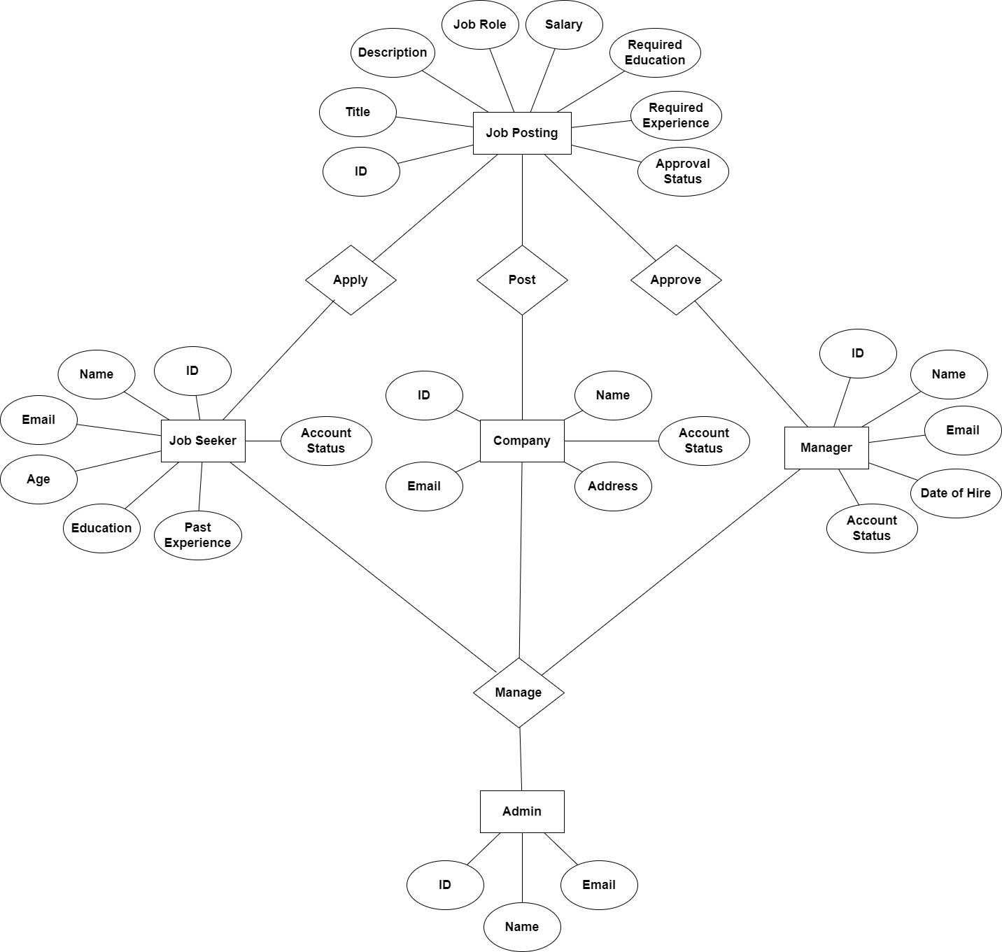

1. **Sequence Diagrams**

**3.1 Login**

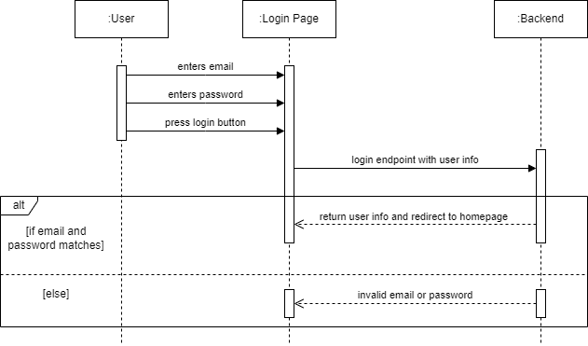

**3.2 Logout**

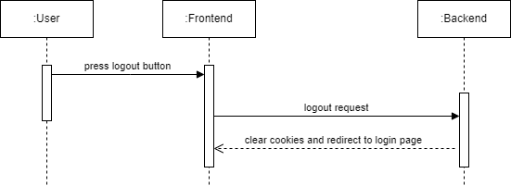

**3.3 Signu****p**

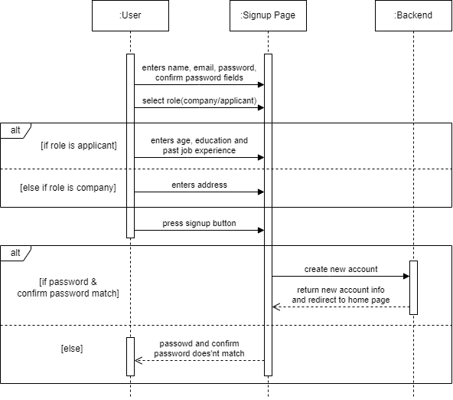

**3.4 Manage Accounts**

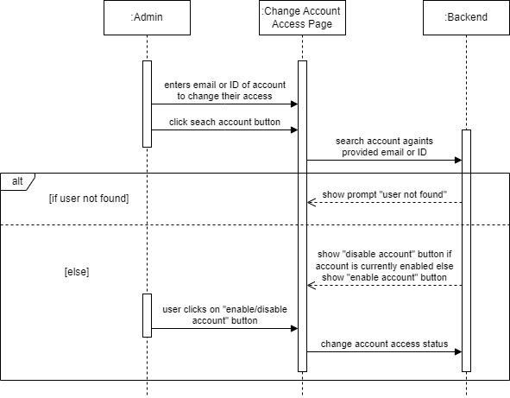

**3.5 Access Statistics**

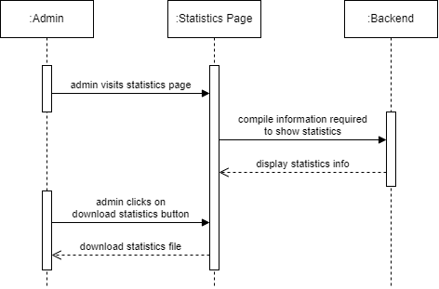

**3.6 Access Job Postings**

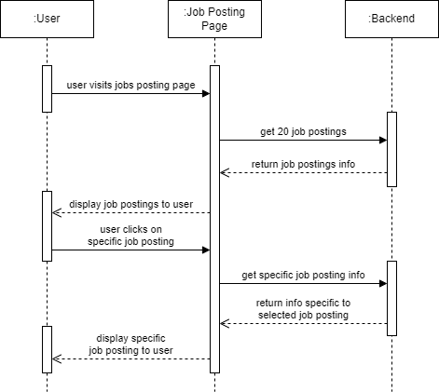

**3.7 Search Jobs**

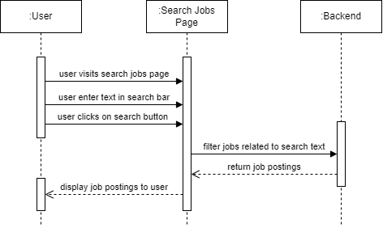

**3.8 Filter Jobs**

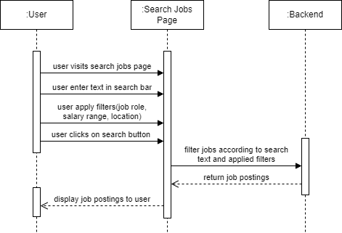

**3.9 Apply for Jobs**

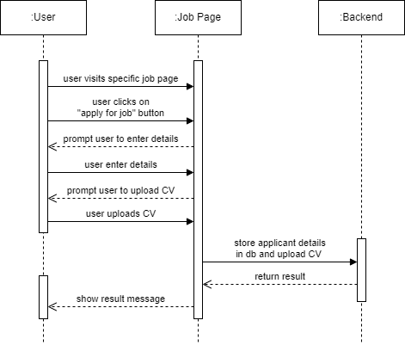

**3.10 Upload CVs**

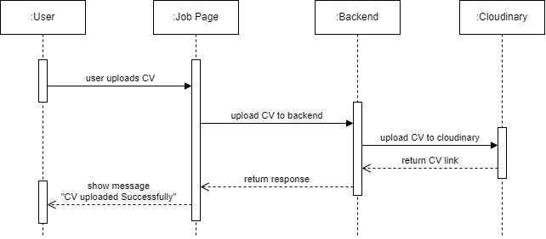

**3.11 Publish Job Postings**

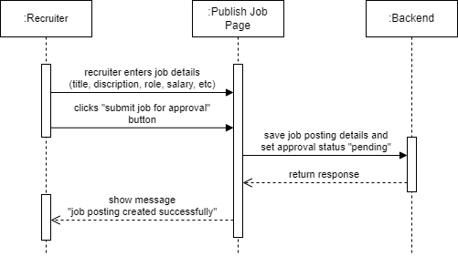

**3.12 View and Filter Applicants**

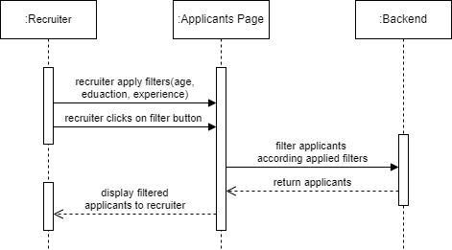

**3.13 Approve Job Postings**

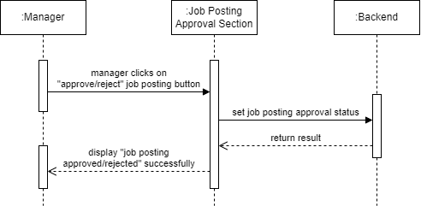

**3.13 Select Applicant for Job**

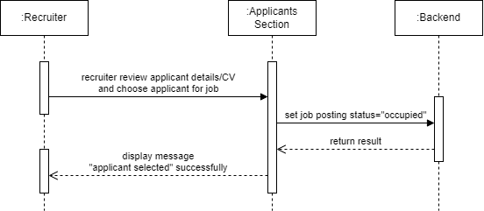

1. **Architecture Design Diagram**

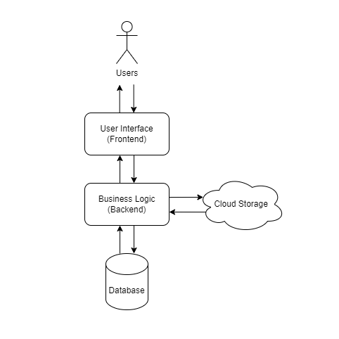

1. **Class Diagram**

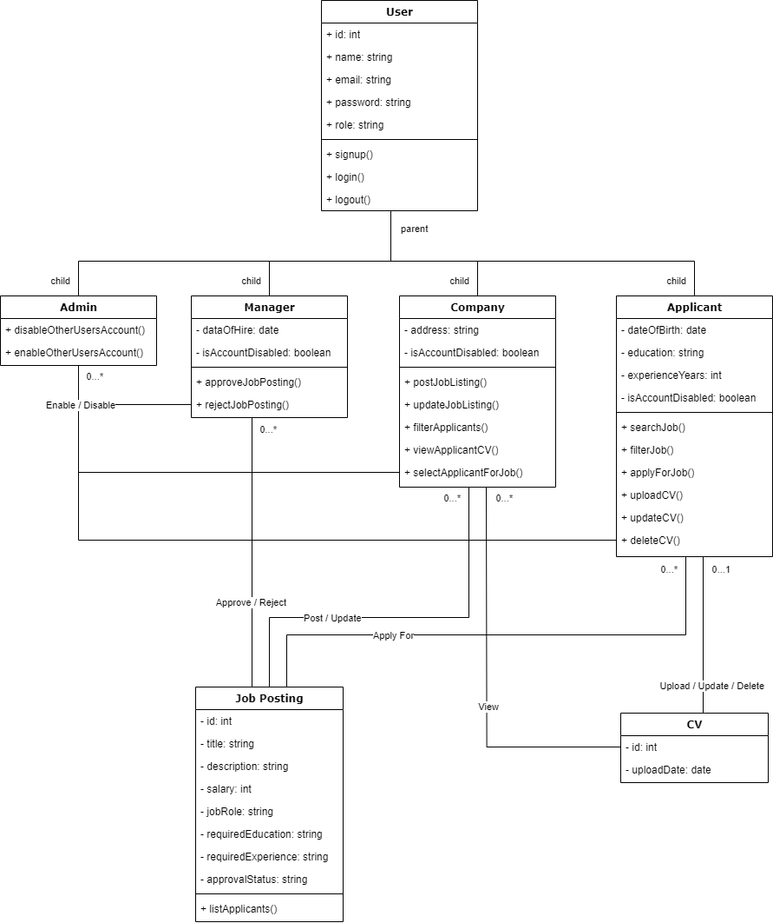

1. **Database Design**

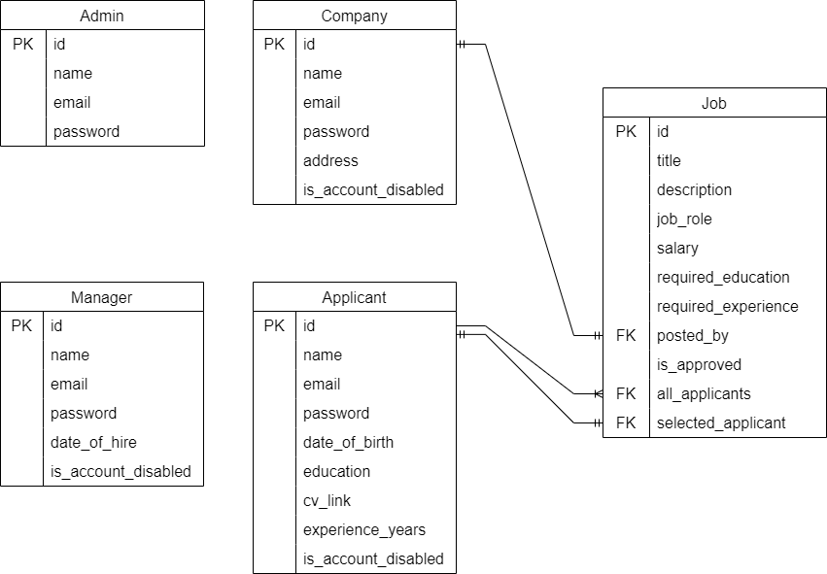

1. **Interface Design**

**1. Sign Up Page**

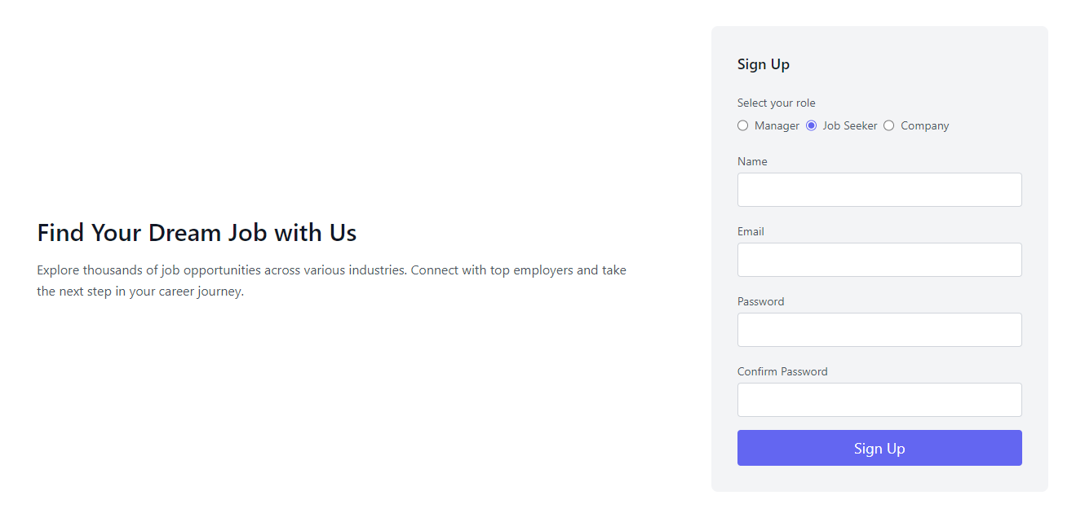

**2. Login Page**

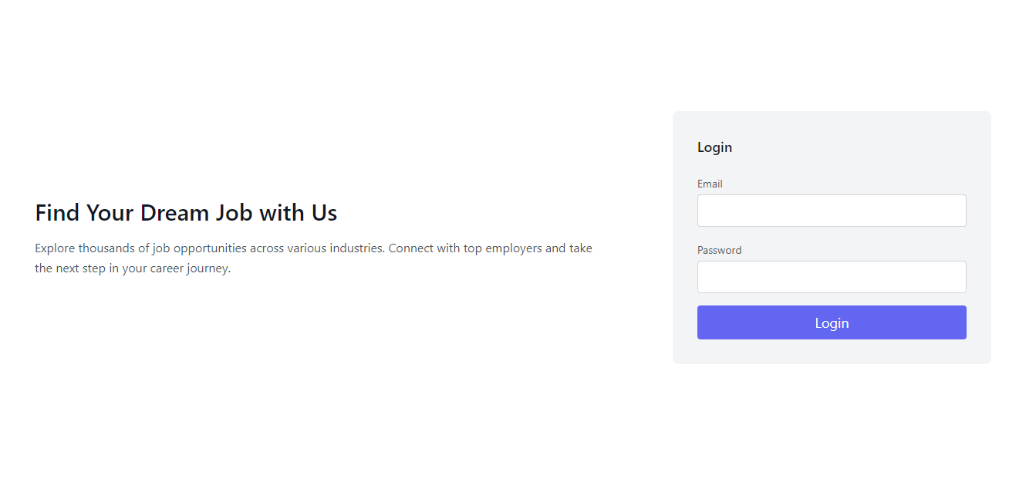

**3. Home Page**

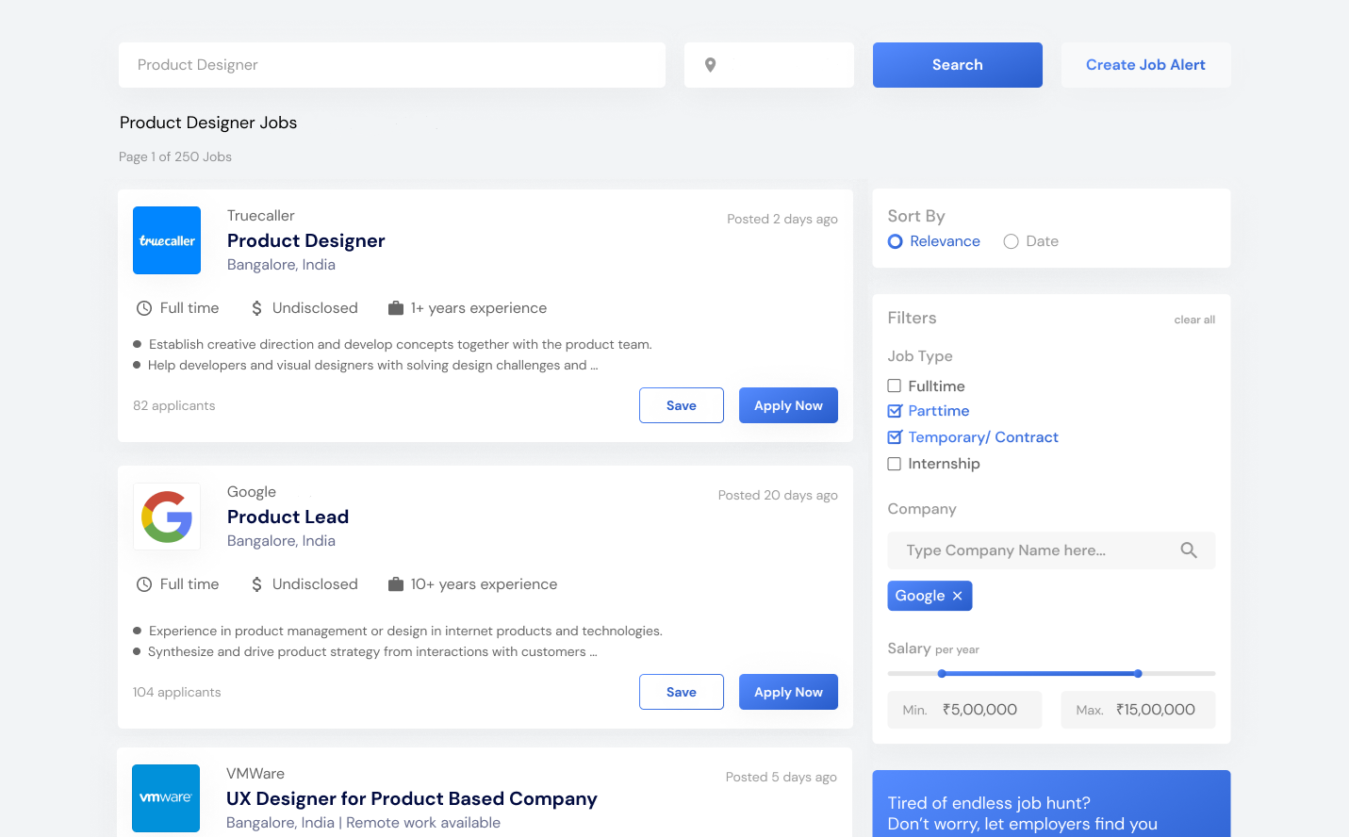

1. **Test Cases**
2. **Login**

| **Test Case ID** | **Description** | **Preconditions** | **Test Steps** | **Expected Result** |
| --- | --- | --- | --- | --- |
| TC01_01 | Verify user can navigate to the login page | None | 1. Open the application  2. Navigate to login page | Login page is displayed |
| TC01_02 | Verify user can enter credentials | User is on the login page | 1. Enter username  2. Enter password | Credentials are entered |
| TC01_03 | Verify user can submit the login form | User has entered credentials | 1. Click on the login button | Login form is submitted |
| TC01_04 | Verify system grants access with correct credentials | User has submitted the login form | 1. Submit valid credentials | User is logged in and redirected to the dashboard |
| TC01_05 | Verify system prompts for incorrect credentials | User has submitted the login form | 1. Submit invalid credentials | Error message is displayed |

1. **Logout**

| **Test Case ID** | **Description** | **Preconditions** | **Test Steps** | **Expected Result** |
| --- | --- | --- | --- | --- |
| TC02_01 | Verify user can navigate to the logout button | User is logged in | 1. Click on the logout button | User is logged out and redirected to the login page |

1. **Signup**

| **Test Case ID** | **Description** | **Preconditions** | **Test Steps** | **Expected Result** |
| --- | --- | --- | --- | --- |
| TC03_01 | Verify user can navigate to the signup page | None | 1. Open the application  2. Navigate to signup page | Signup page is displayed |
| TC03_02 | Verify user can select role | User is on the signup page | 1. Select role (Applicant/Company) | Role is selected |
| TC03_03 | Verify user can enter required details | User is on the signup page | 1. Enter required details | Details are entered |
| TC03_04 | Verify user can submit the signup form | User has entered required details | 1. Click on the signup button | Signup form is submitted |
| TC03_05 | Verify system creates new account | User has submitted the signup form | 1. Submit valid details | New account is created and user is redirected to login page |

1. **Manage Accounts**

| **Test Case ID** | **Description** | **Preconditions** | **Test Steps** | **Expected Result** |
| --- | --- | --- | --- | --- |
| TC04_01 | Verify admin can navigate to Manage Accounts section | Admin is logged in | 1. Navigate to “Manage Accounts” section | “Manage Accounts” section is displayed |
| TC04_02 | Verify admin can select a user account | Admin is in “Manage Accounts” section | 1. Select a user account | User account details are displayed |
| TC04_03 | Verify admin can update user details | Admin has selected a user account | 1. Update user details  2. Save changes | User details are updated |
| TC04_04 | Verify admin can grant/revoke access | Admin has selected a user account | 1. Grant/revoke access  2. Save changes | Access is granted/revoked |

1. **Access Statistics**

| **Test Case ID** | **Description** | **Preconditions** | **Test Steps** | **Expected Result** |
| --- | --- | --- | --- | --- |
| TC05_01 | Verify admin can navigate to Statistics section | Admin is logged in | 1. Navigate to “Statistics” section | “Statistics” section is displayed |
| TC05_02 | Verify admin can view existing statistics | Admin is in “Statistics” section | 1. View existing statistics | Existing statistics are displayed |
| TC05_03 | Verify admin can generate reports | Admin is in “Statistics” section | 1. Select parameters for report  2. Generate report | Report is generated and displayed |

1. **Access Job Postings**

| **Test Case ID** | **Description** | **Preconditions** | **Test Steps** | **Expected Result** |
| --- | --- | --- | --- | --- |
| TC06_01 | Verify user can navigate to job postings section | User is logged in | 1. Navigate to job postings section | Job postings section is displayed |
| TC06_02 | Verify user can view job postings | User is in job postings section | 1. View list of job postings | Job postings are displayed |

1. **View and Search Jobs**

| **Test Case ID** | **Description** | **Preconditions** | **Test Steps** | **Expected Result** |
| --- | --- | --- | --- | --- |
| TC07_01 | Verify user can navigate to job search page | User is logged in | 1. Navigate to job search page | Job search page is displayed |
| TC07_02 | Verify user can enter search criteria | User is on job search page | 1. Enter search criteria | Search criteria is entered |
| TC07_03 | Verify user can view search results | User has entered search criteria | 1. View search results | Search results are displayed |

1. **Filter Jobs**

| **Test Case ID** | **Description** | **Preconditions** | **Test Steps** | **Expected Result** |
| --- | --- | --- | --- | --- |
| TC08_01 | Verify user can apply filters to job search | User is logged in | 1. Navigate to job search page  2. Apply filters | Filters are applied and results are displayed |

1. **Apply for Jobs**

| **Test Case ID** | **Description** | **Preconditions** | **Test Steps** | **Expected Result** |
| --- | --- | --- | --- | --- |
| TC09_01 | Verify user can navigate to a job posting | User is logged in | 1. Navigate to a job posting | Job posting is displayed |
| TC09_02 | Verify user can apply for a job | User is on a job posting | 1. Click on apply button  2. Submit application details | Application is submitted and confirmed |

1. **Upload CVs**

| **Test Case ID** | **Description** | **Preconditions** | **Test Steps** | **Expected Result** |
| --- | --- | --- | --- | --- |
| TC10_01 | Verify user can upload CV | User is applying for a job | 1. Upload CV while applying | CV is uploaded and stored |

1. **Publish Job Postings**

| **Test Case ID** | **Description** | **Preconditions** | **Test Steps** | **Expected Result** |
| --- | --- | --- | --- | --- |
| TC11_01 | Verify company can create and publish job posting | Company is logged in | 1. Navigate to job postings section  2. Create a job posting  3. Publish job posting | Job posting is published and visible |

1. **View and Filter Applicants**

| **Test Case ID** | **Description** | **Preconditions** | **Test Steps** | **Expected Result** |
| --- | --- | --- | --- | --- |
| TC12_01 | Verify company can view and filter applicants | Company is logged in | 1. Navigate to applicants section  2. Apply filters  3. View filtered applicants | Filtered applicants are displayed |

1. **Approve Job Postings**

| **Test Case ID** | **Description** | **Preconditions** | **Test Steps** | **Expected Result** |
| --- | --- | --- | --- | --- |
| TC13_01 | Verify manager can approve job postings | Manager is logged in | 1. Navigate to job approval section  2. Review job postings  3. Approve/reject job postings | Job postings are approved/rejected |

1. **Upload Media Related to Job Postings**

| **Test Case ID** | **Description** | **Preconditions** | **Test Steps** | **Expected Result** |
| --- | --- | --- | --- | --- |
| TC14_01 | Verify manager/company can upload media to job postings | Manager/Company is logged in | 1. Navigate to a job posting  2. Upload media  3. Save job posting | Media is uploaded and linked to job posting |

1. **Access Uploaded CVs**

| **Test Case ID** | **Description** | **Preconditions** | **Test Steps** | **Expected Result** |
| --- | --- | --- | --- | --- |
| TC15_01 | Verify manager/company can navigate to the applicants section | Manager/Company is logged in | 1. Navigate to applicants section | Applicants section is displayed |
| TC15_02 | Verify manager/company can view uploaded CVs of applicants | Manager/Company is in the applicants section | 1. View list of applicants  2. Click on an applicant to view uploaded CV | Uploaded CV of the selected applicant is displayed |